RECIPE

Pie crust (2 10” crusts

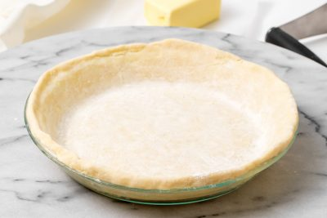

# Ingredients

* 1 cup butter
* 2 ⅔ cups All purpose flour
* 1 tsp salt (less if using salted butter/ making with a savory inside)
* 7 to 8 tbsp ice water

# Preparation

1. Cut butter into flour and salt until it resembles coarse meal.
2. Add water one tbls at a time
3. Toss together until mixture just holds together to form a ball
4. Cover dough with plastic wrap and chill for ½ hour
5. Cut dough in half and roll one half into a ball
6. Flour dough, flat surface and a rolling pin, and roll out
7. Repeat with the second ball of dough
8. Bake as pie directs